

Design Document

Team Members

**Gabriel Grimberg** – *C15478448*

**Zan Smirnov** – *C15437072*

**Daniel Vegera** – *C15469578*

VitonBet

Design Document

Revision 1.0

Table of Contents

Group details 1

Introduction 3

Description about the app 3

Application Features 4

UML Class Diagram 5

Screen Flows 7

Age Verification Screen 7

Log In Screen 7

Registration Screen 8

Main Menu Screen 8

Betting Screen 9

Casino Screen 9

Cash Out Screen 10

Use Case 11

Database Design 14

Introduction

Description About VitonBet

VitonBet is an upcoming betting app that will be available on devices that are running Android. With plenty of betting applications out there for different types of companies, VitonBet will be a unique betting app with unique and smart features such as minimising addiction. As it is a gambling app and as we all know gambling can cause a bad habit in a person’s life, we will be mainly focusing on reduced addiction and more fun. This app will not use real currency as it violates the Google Play store regulations, so we must follow the rules. So, without real currency VitonBet will be a mock up to what an actual real betting app is.

VitonBet is an application that will be developed by three Computer Science students in Dublin Institute of Technology with the names of **Gabriel Grimberg**, **Zan Smirnov** and **Daniel Vegera**. This application is scheduled to be developed for the Mobile Software Development module in their third year of our course.

We have done our research and checked out other betting applications such as Bet365 and Paddy Power. The features that caught the eye for us was the casino mode in Paddy Power and the betting style in Bet365. We will use these features as an idea for VitonBet and we will implement our own designed betting application.

*The minimum that VitonBet will have is as follows that will be sufficient for a stable release:*

* **SQLite** database to store data.
* An input screen where the user must enter data.
* Include a list which is populated with data from the database.
* Underlying operations on the database such as **INSERT**, **UPDATE**, **SELECT**, **DELETE** usage on the database.
* **Multi-thread**, not just running on one thread as it will slow down the app.
* Registration for users to create their own accounts and login for users to be able to login into their accounts and view their profile, change anything they want in their profile and more.
* Users could place bets on events such as eSports games and users being able to create events where other users can enter.

Application Features

VitonBet is a betting app alongside a gambling app where users will place bets on eSports. Users will be able to see the odds and to bet on that specific player or team to win a game if chosen in the gaming genre and for this to happen users will need to be registered. **Registration** and **Login** will be fundamental in this app that will store the user’s information such as name, phone number, total winnings and so on.

A **navigation bar** will also be implemented in VitonBet as without a doubt it is essential, a navigation bar will allow the user to navigate to various of eSports to place bets on, will be able to navigate to different types of modes such as **casino** or **roulette**.

**Live odds,** odds will not be static meaning they will not stay the same, odds will change every hour or depending on the current given event, for example in a game if a team wins back to back games they will be favorite to win their next game, so the probability will increase for them, although they can still lose.

**Users creating their own events**, events such as entry fee is for example 50 euro and the users who enter must guess the teams that will win their match in a game. The user with the most accuracy takes home the grand prize which can be like 500 euro. This is slightly the same as an accumulator where you pick the teams that will win their matches although if one team loses then they are out, no payout for highest accuracy.

**Accumulator**, as explained above the users picks the people he/she thinks will win, the more teams or people on the accumulator hence the more teams or people that the user picks the greater the odds and the greater payout.

**Modes**, other than just bets, a bonus feature that VitonBet will have is different type of modes such as **casino** and **roulette**.

Users may run out of money and there will be no other option but to input their real money into the app to use, although since we’re not going for that approach for the reasons above we will create **Advertisements** which users can click on and watch to obtain some currency to use to place bets or gamble in the casino.

**Community**, a bonus feature that could be implemented where users can discuss different types of strategies and potential wins. Overall anything that relates to the app can be discussed here.

Mainly for a stable release we would like to get the basics done first such as accounts being created and users being able to place bets and create events, after that we can add in new features and optimize the app to improve the performance and the quality.

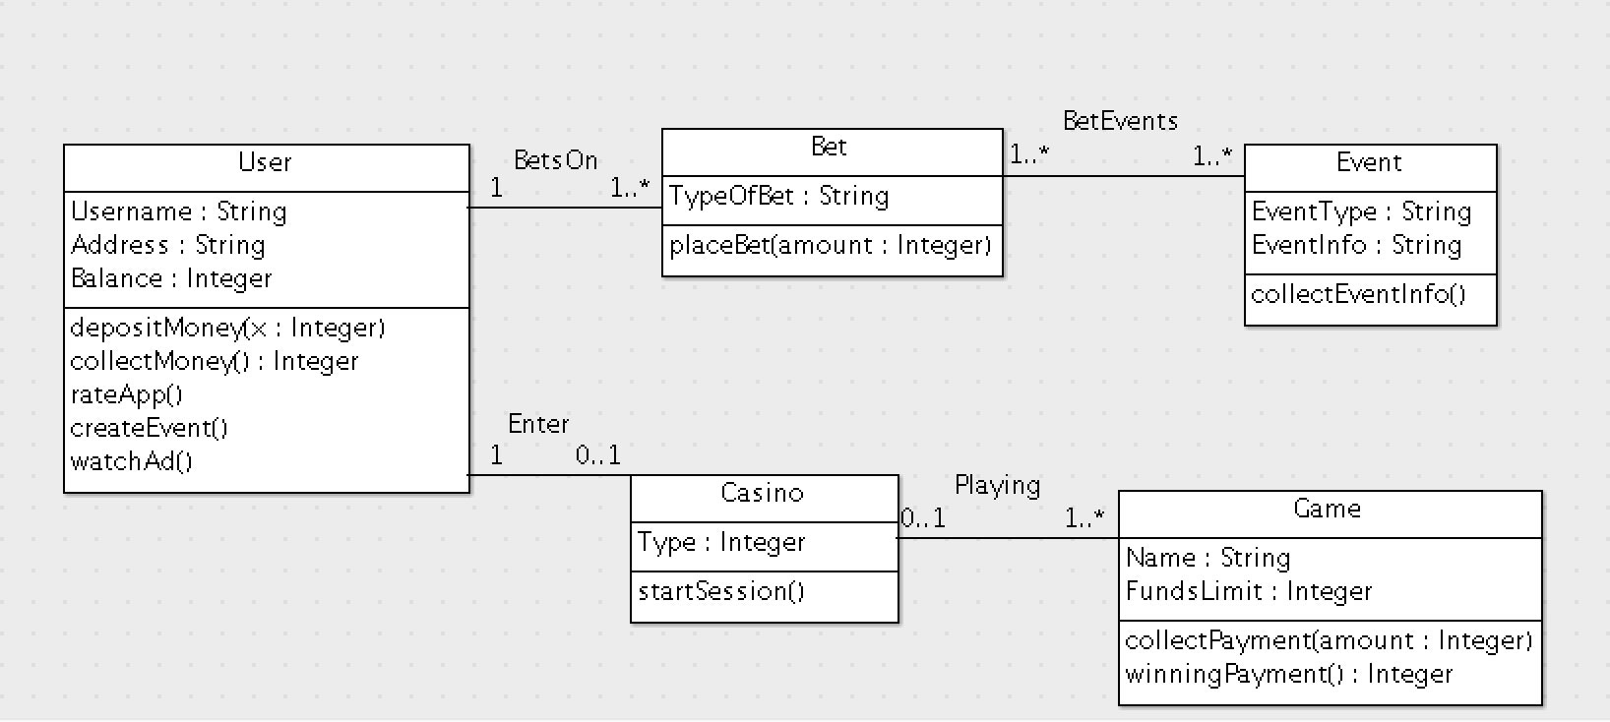VitonBet UML Class Diagram

**User Class**

The user class diagram will hold attributes such as username which has to be unique, address and balance. Balance will be the amount of funds a user has.

The user will be able to deposit money to use in the app to place bets or use it while gambling in the casino.

The user will be able to collect his/her winnings if they make any, from placing bets or casino.

Rating the apple will allow the user to share his/her thoughts on the app while getting some extra funds to use in VitonBet. This is a once off feature although it will be re-enabled every new version.

Watching an ad will grant the user some extra funds too.

The user will be able to create an event.

**Bet Class**

A user can place bets on one to many (unlimited) bets as long as the user has the funds for it.

The user will be able to place a bet and enter in the amount of funds desired.

**Event Class**

Every bet must have an event information. Toggling the bet class will call the event class to display the information about the event, so extended information about the bet.

**Casino Class**

A user will only be able to enter the casino once and not in multi sessions, for example the user can have three phones, using the same account but only the first account that enters the casino will be able to play, session key will be ideal here to control this.

**Game Class**

One casino can have various types of games such as roulette.

The game will be able to collect the payment from the user and add funds to the user if the user manages to win.

VitonBet Screen Flows

**Age Verification Screen**

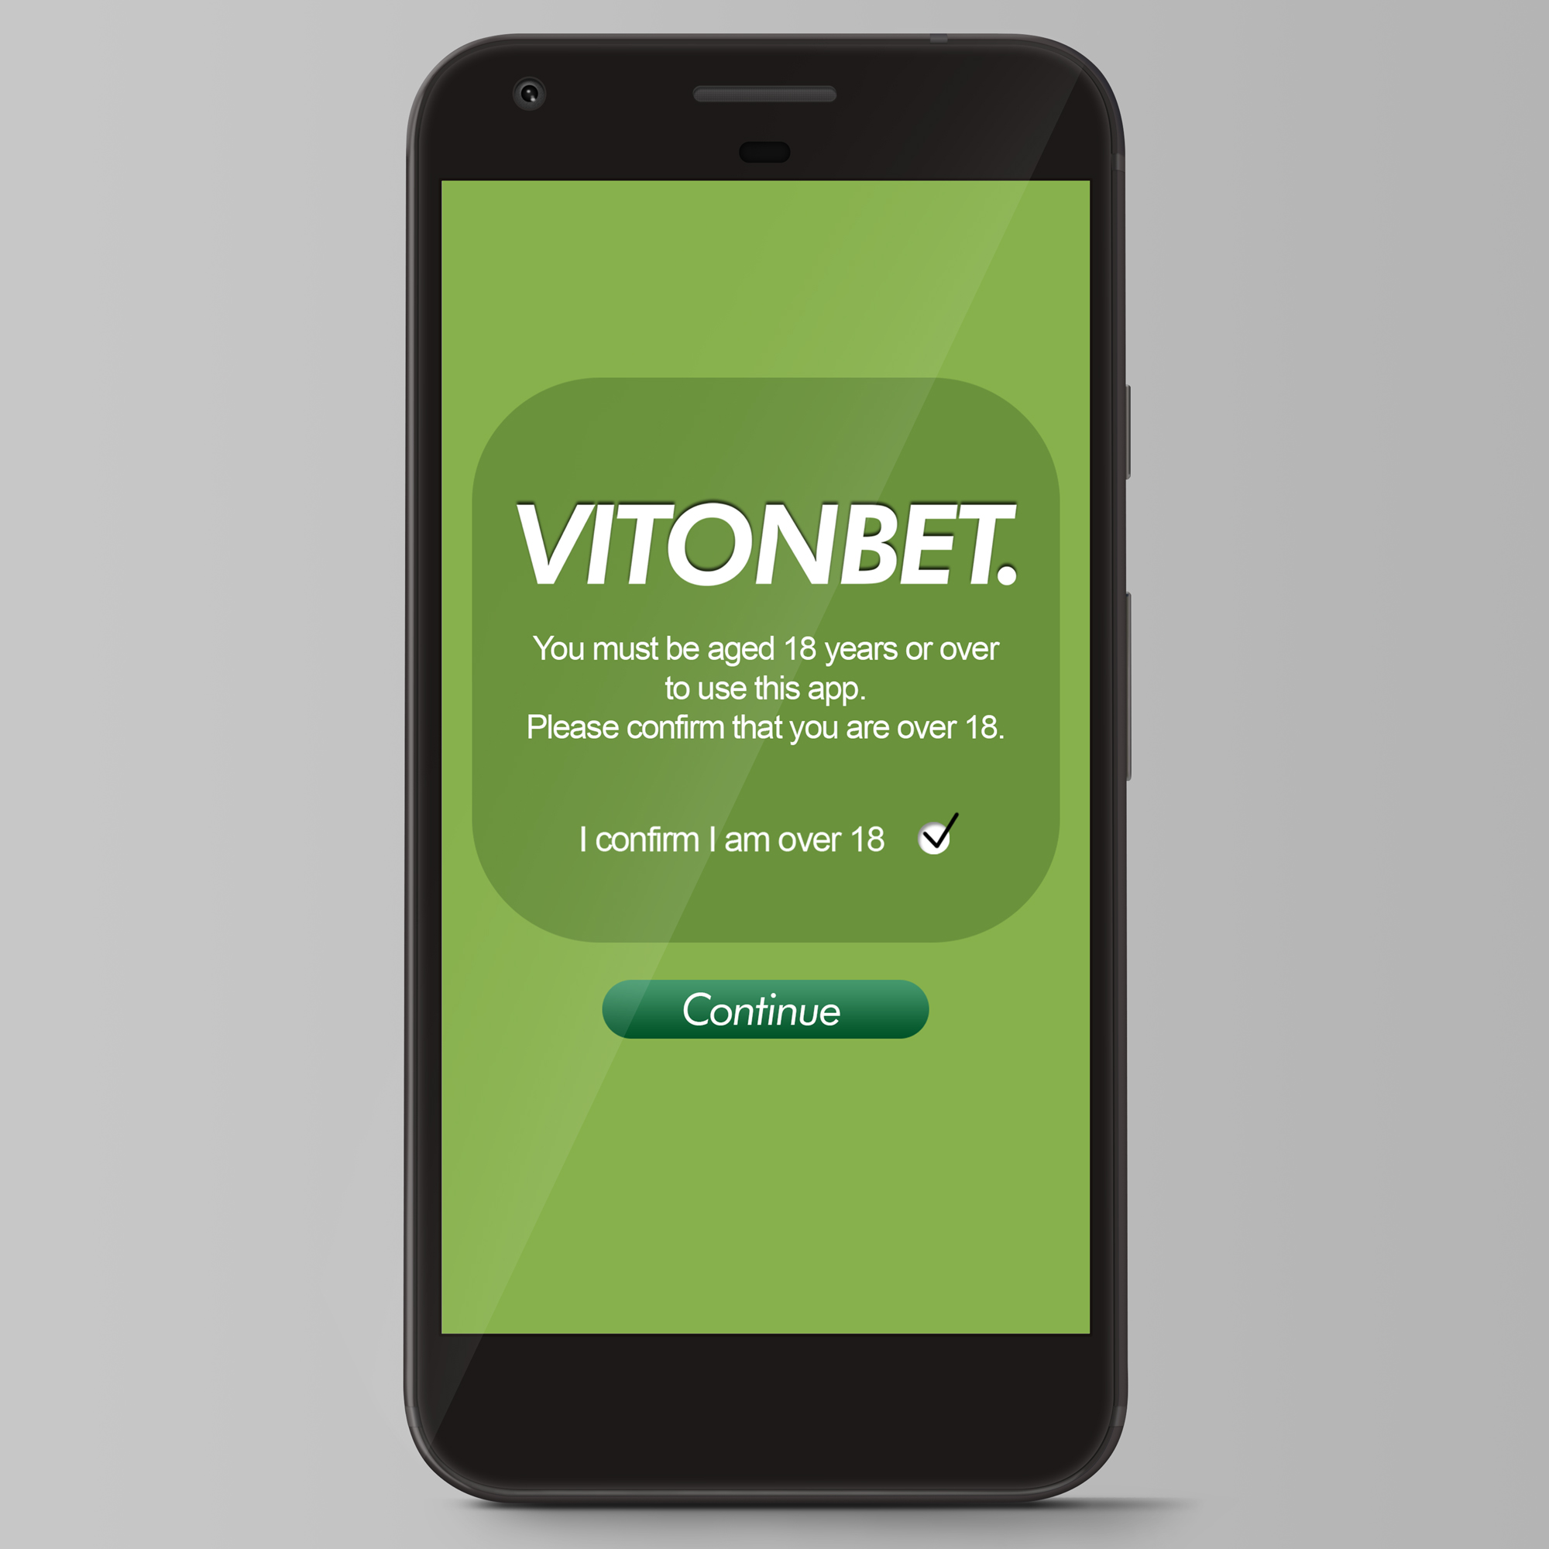

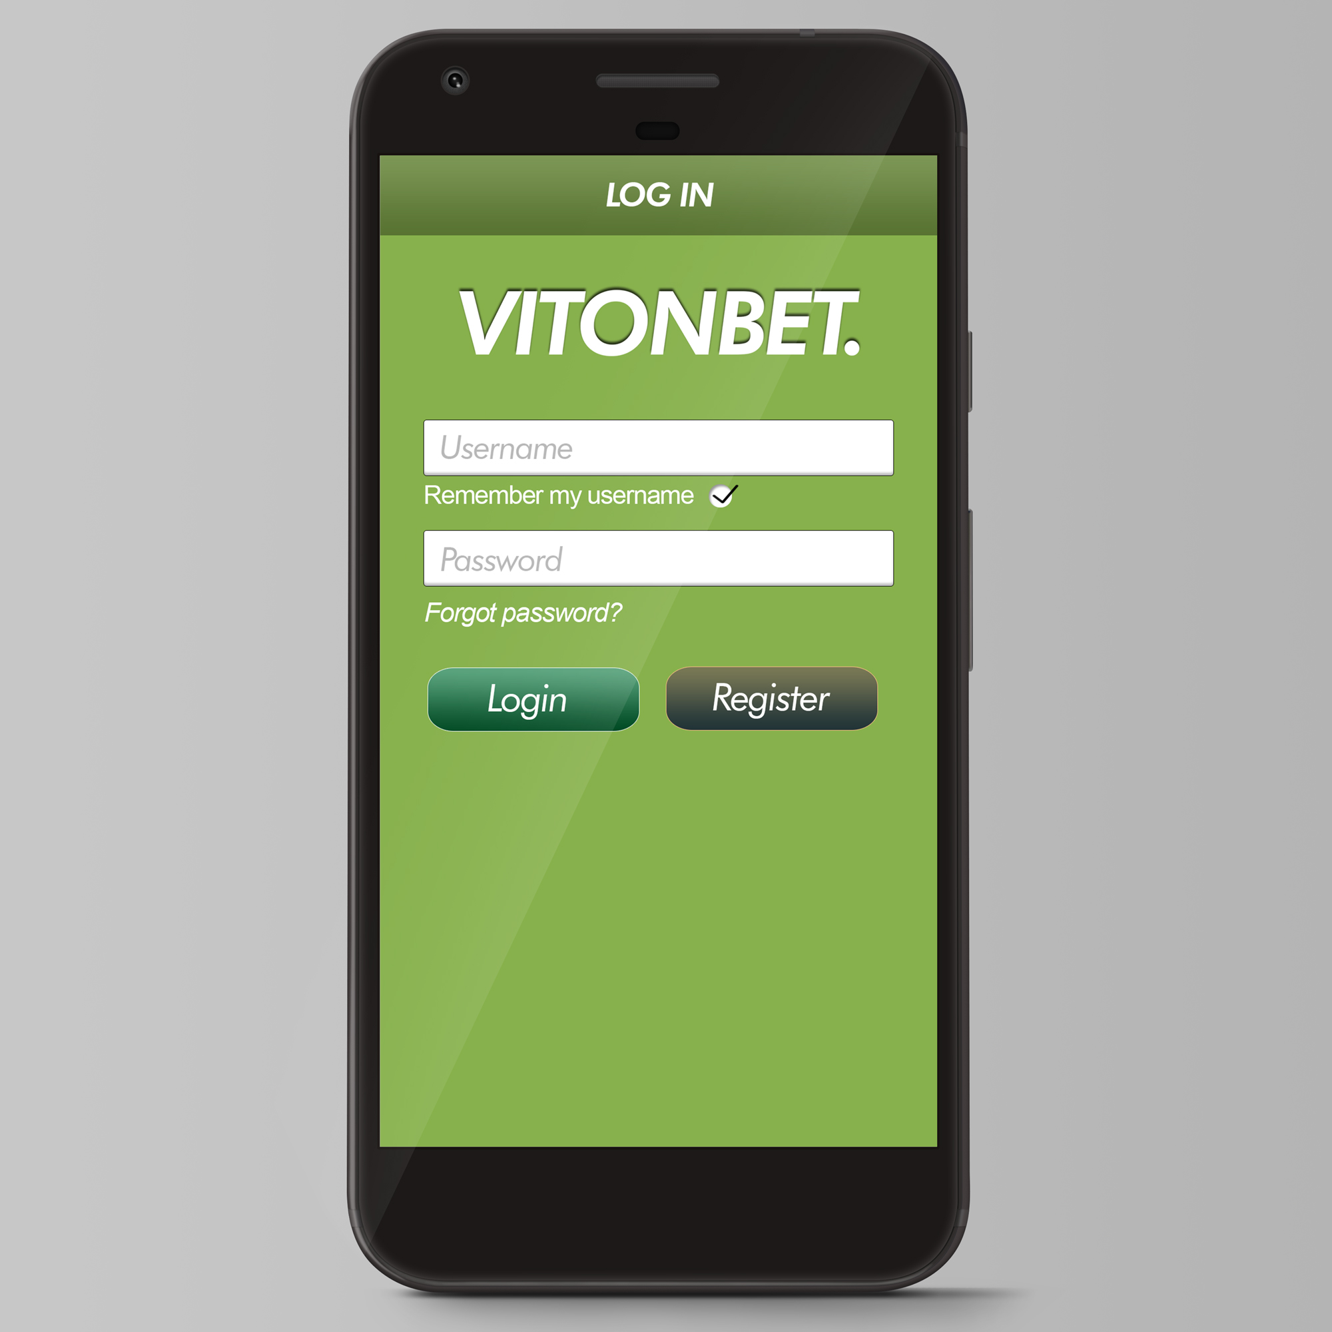**Log In Screen**

**Registration Screen**

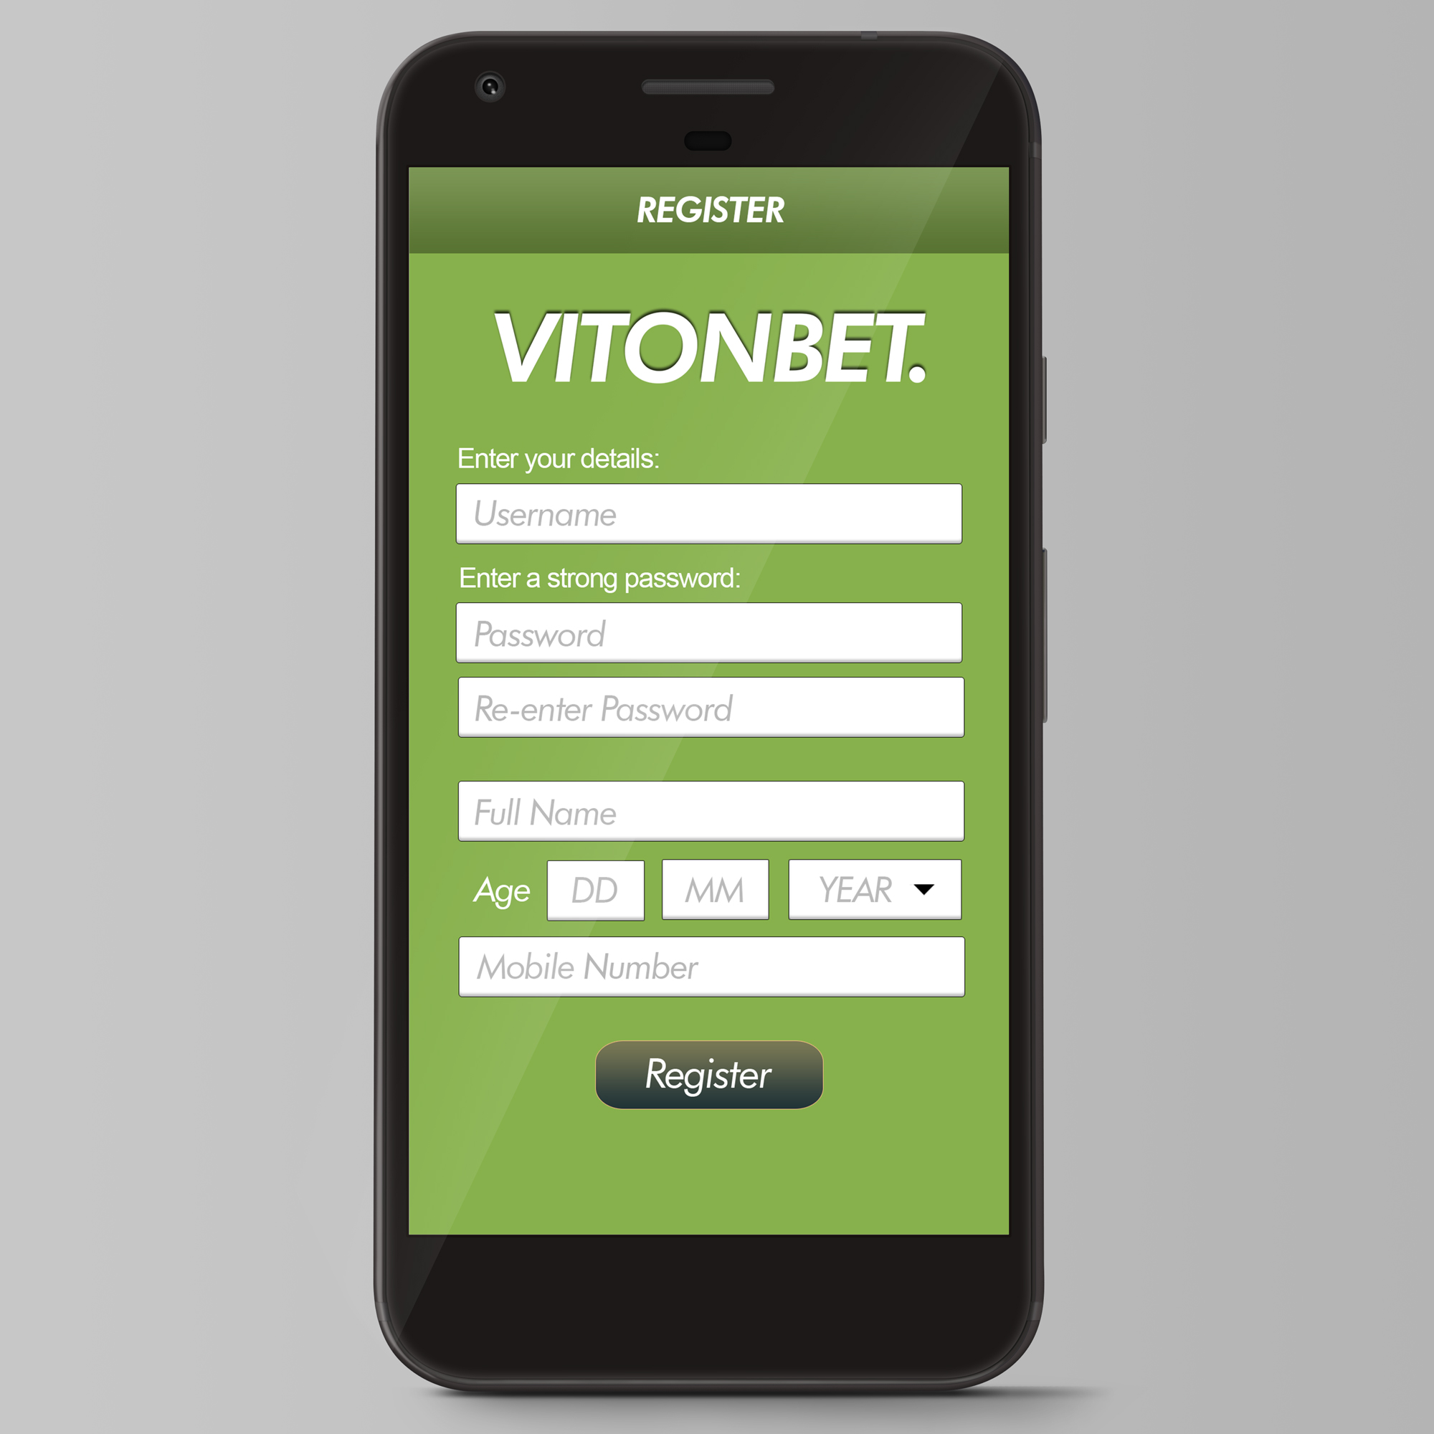

**Main Menu Screen**

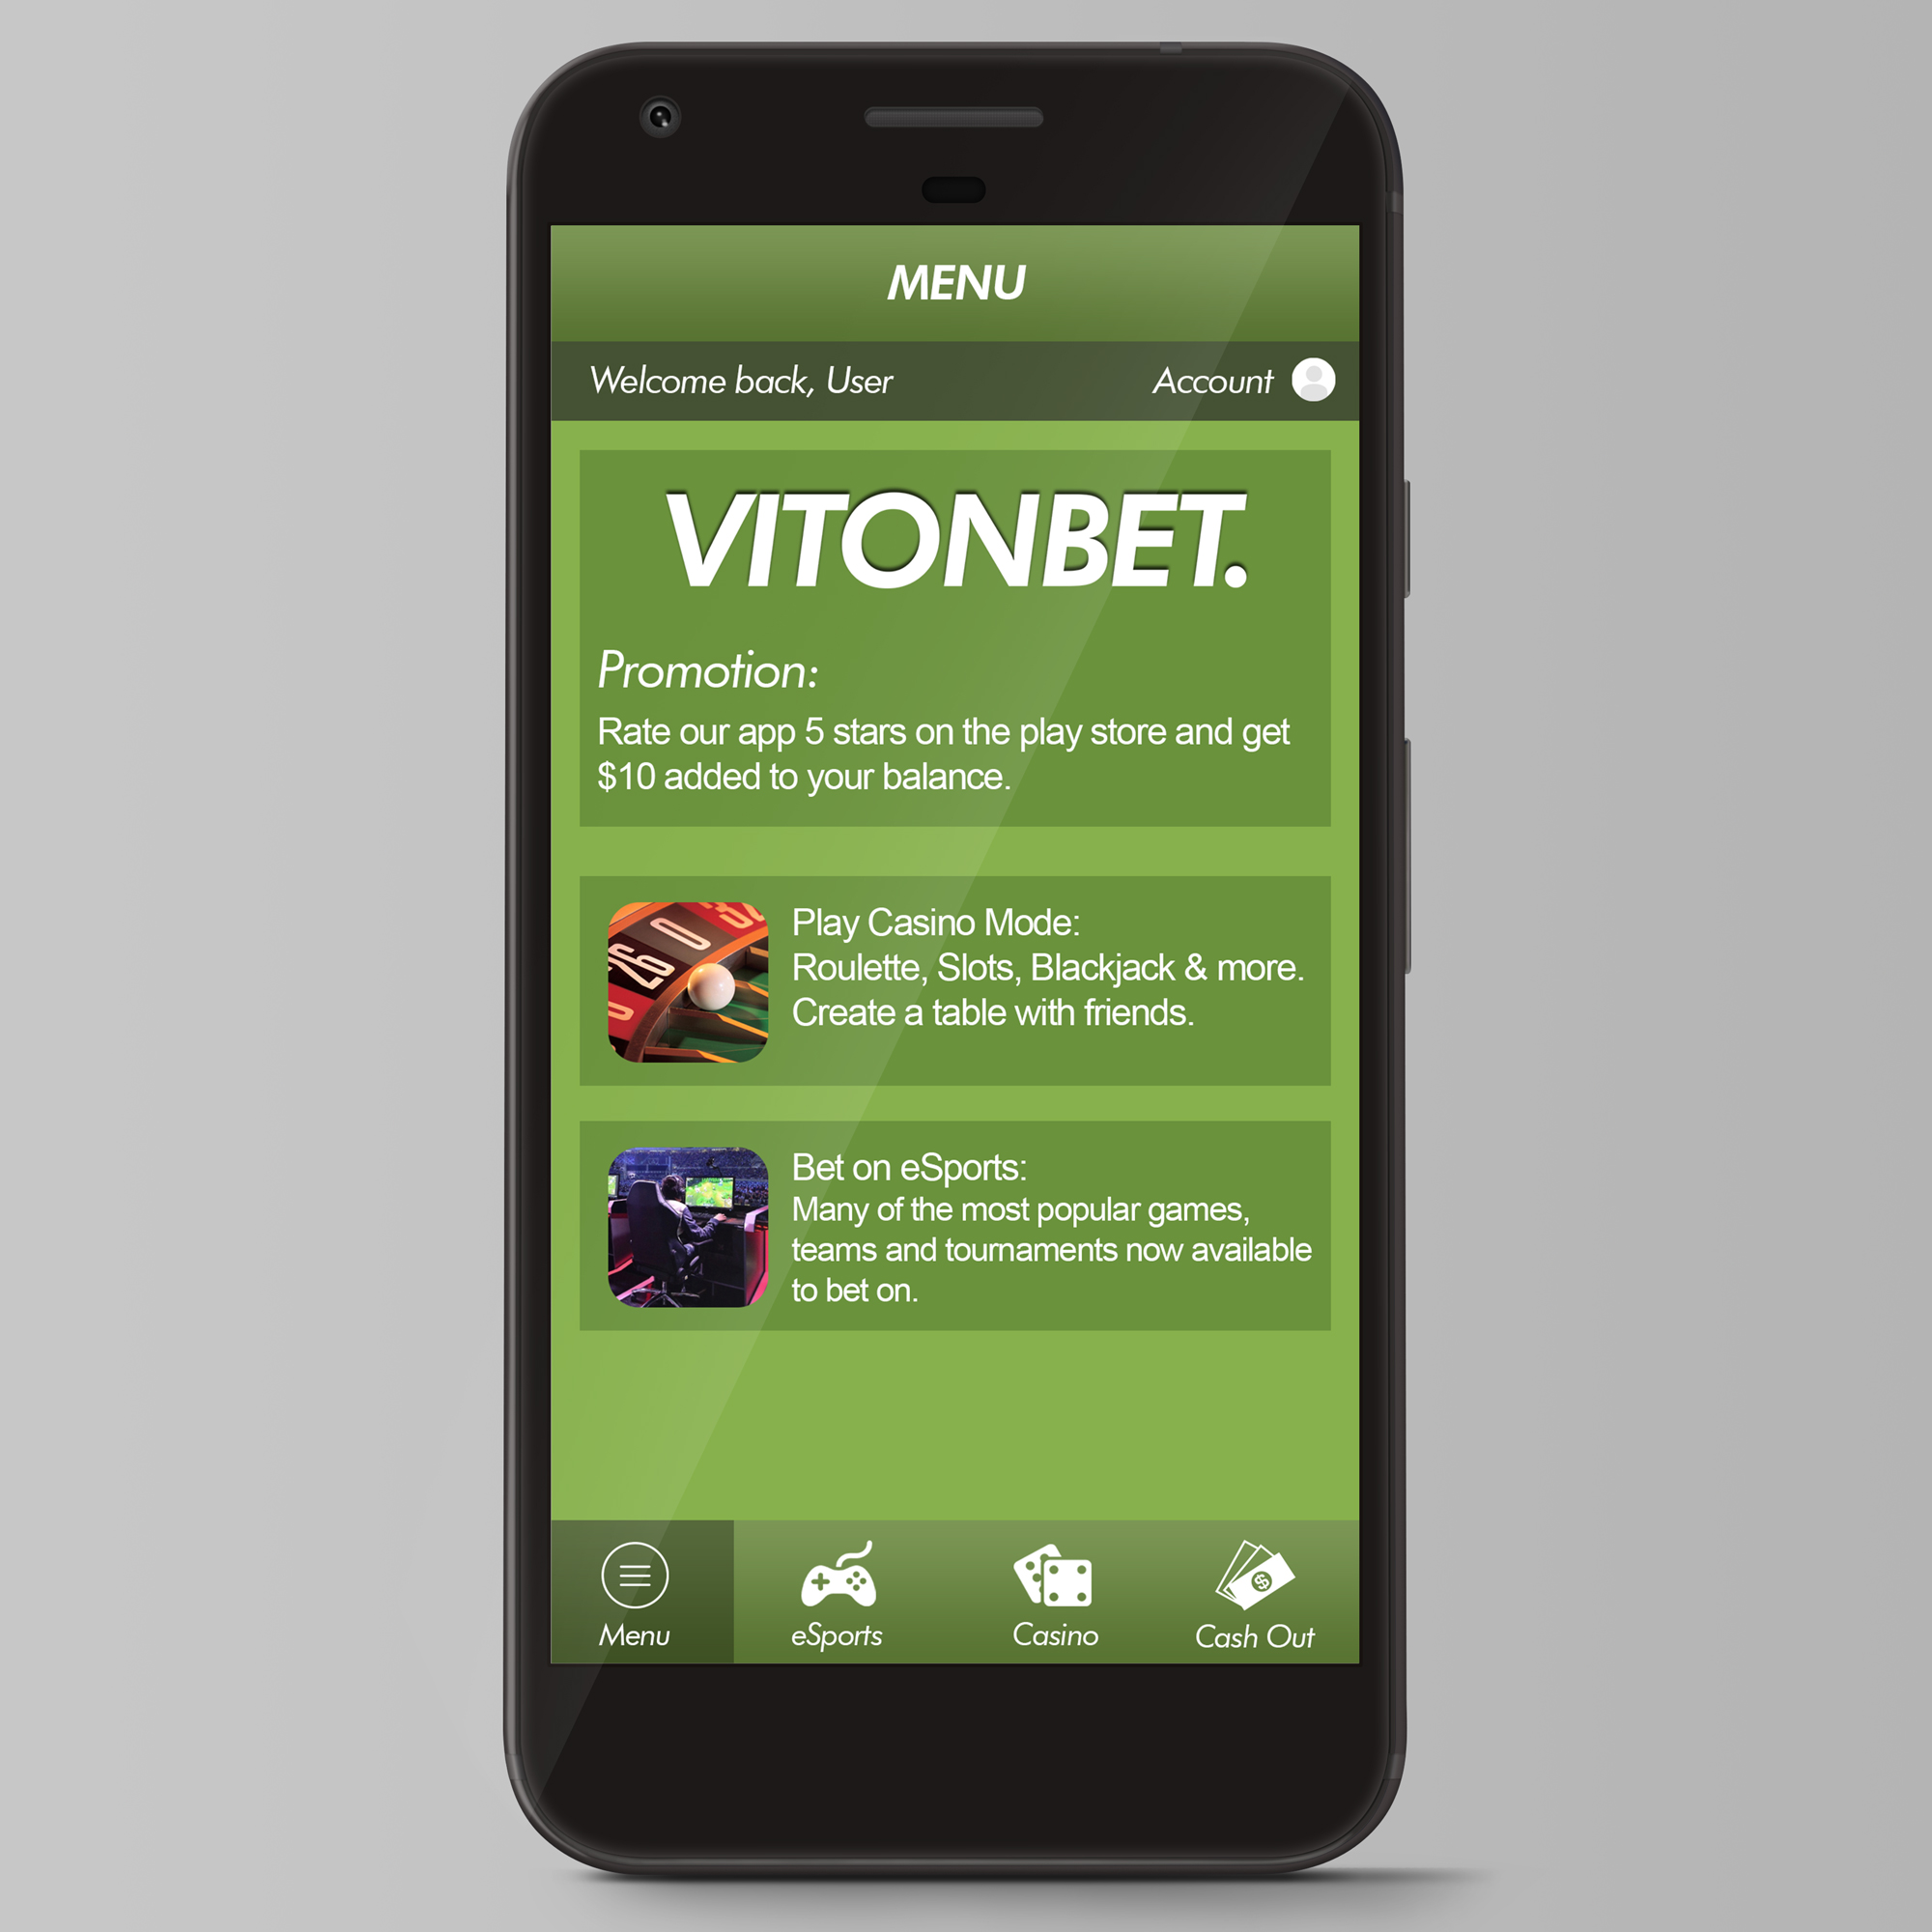

**Betting Screen**

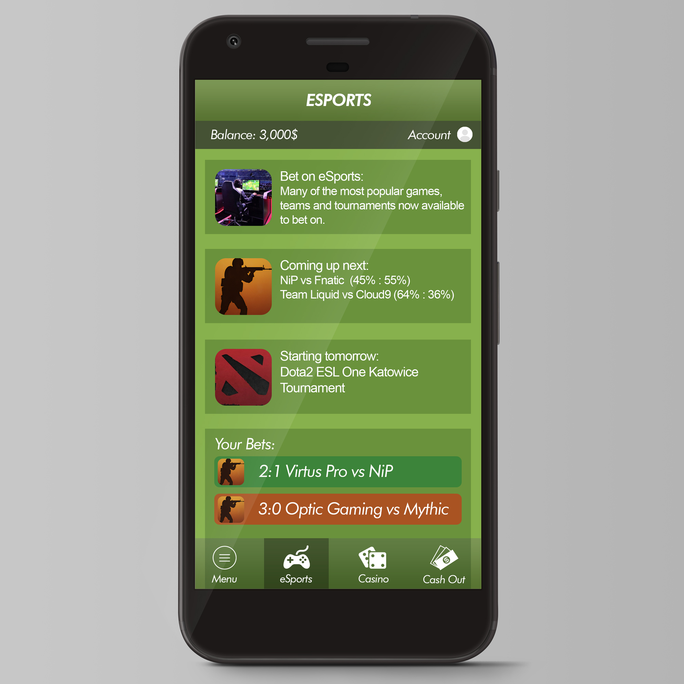

**Casino Screen**

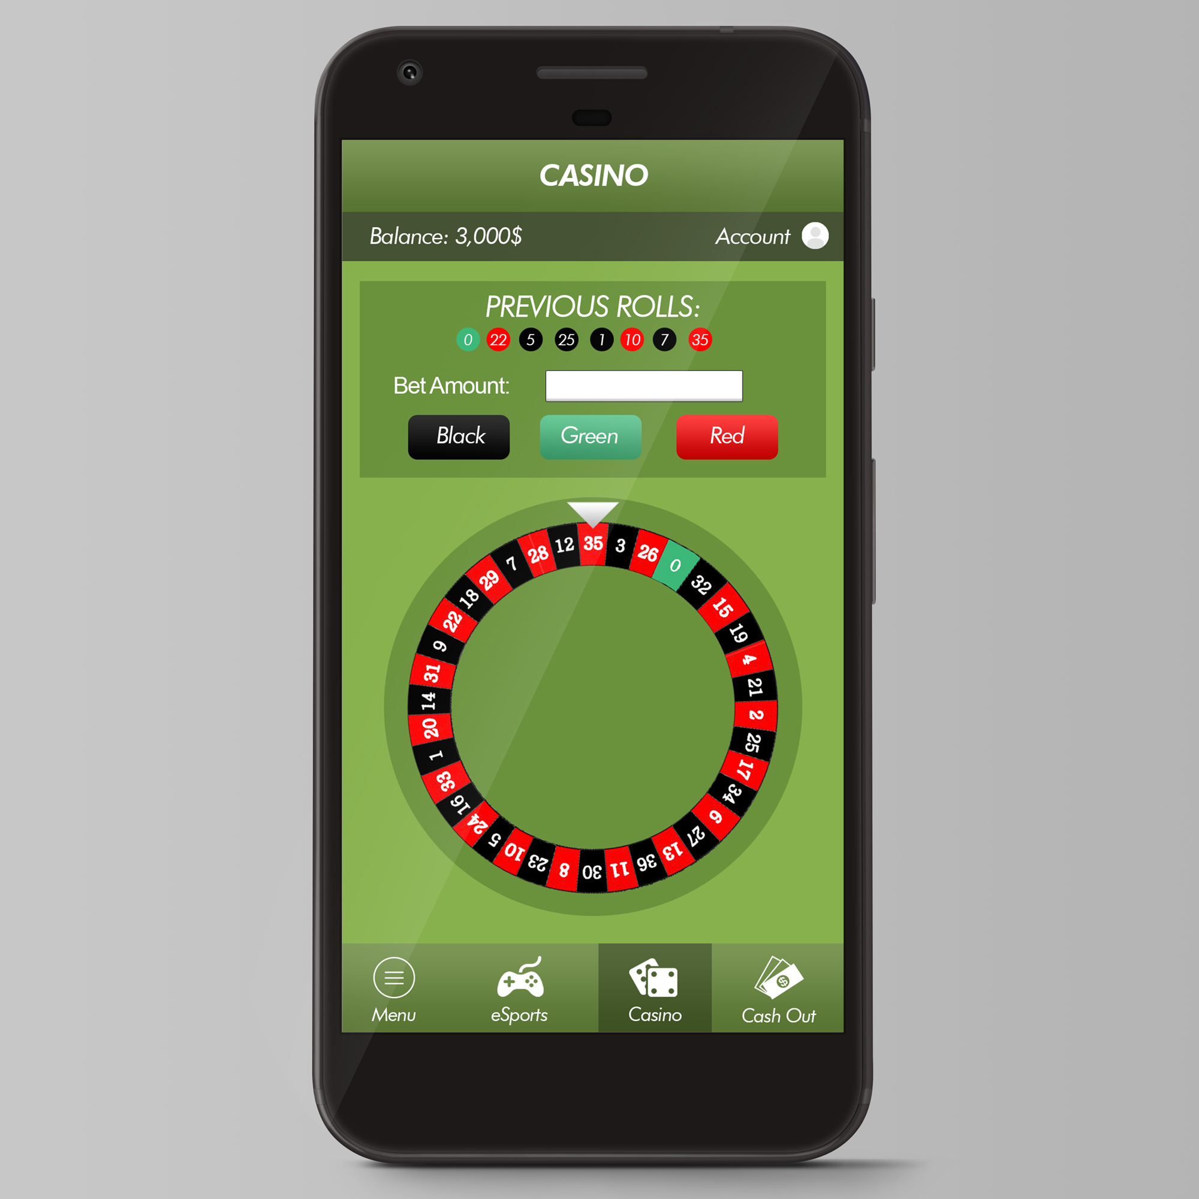

**Cash Out Screen**

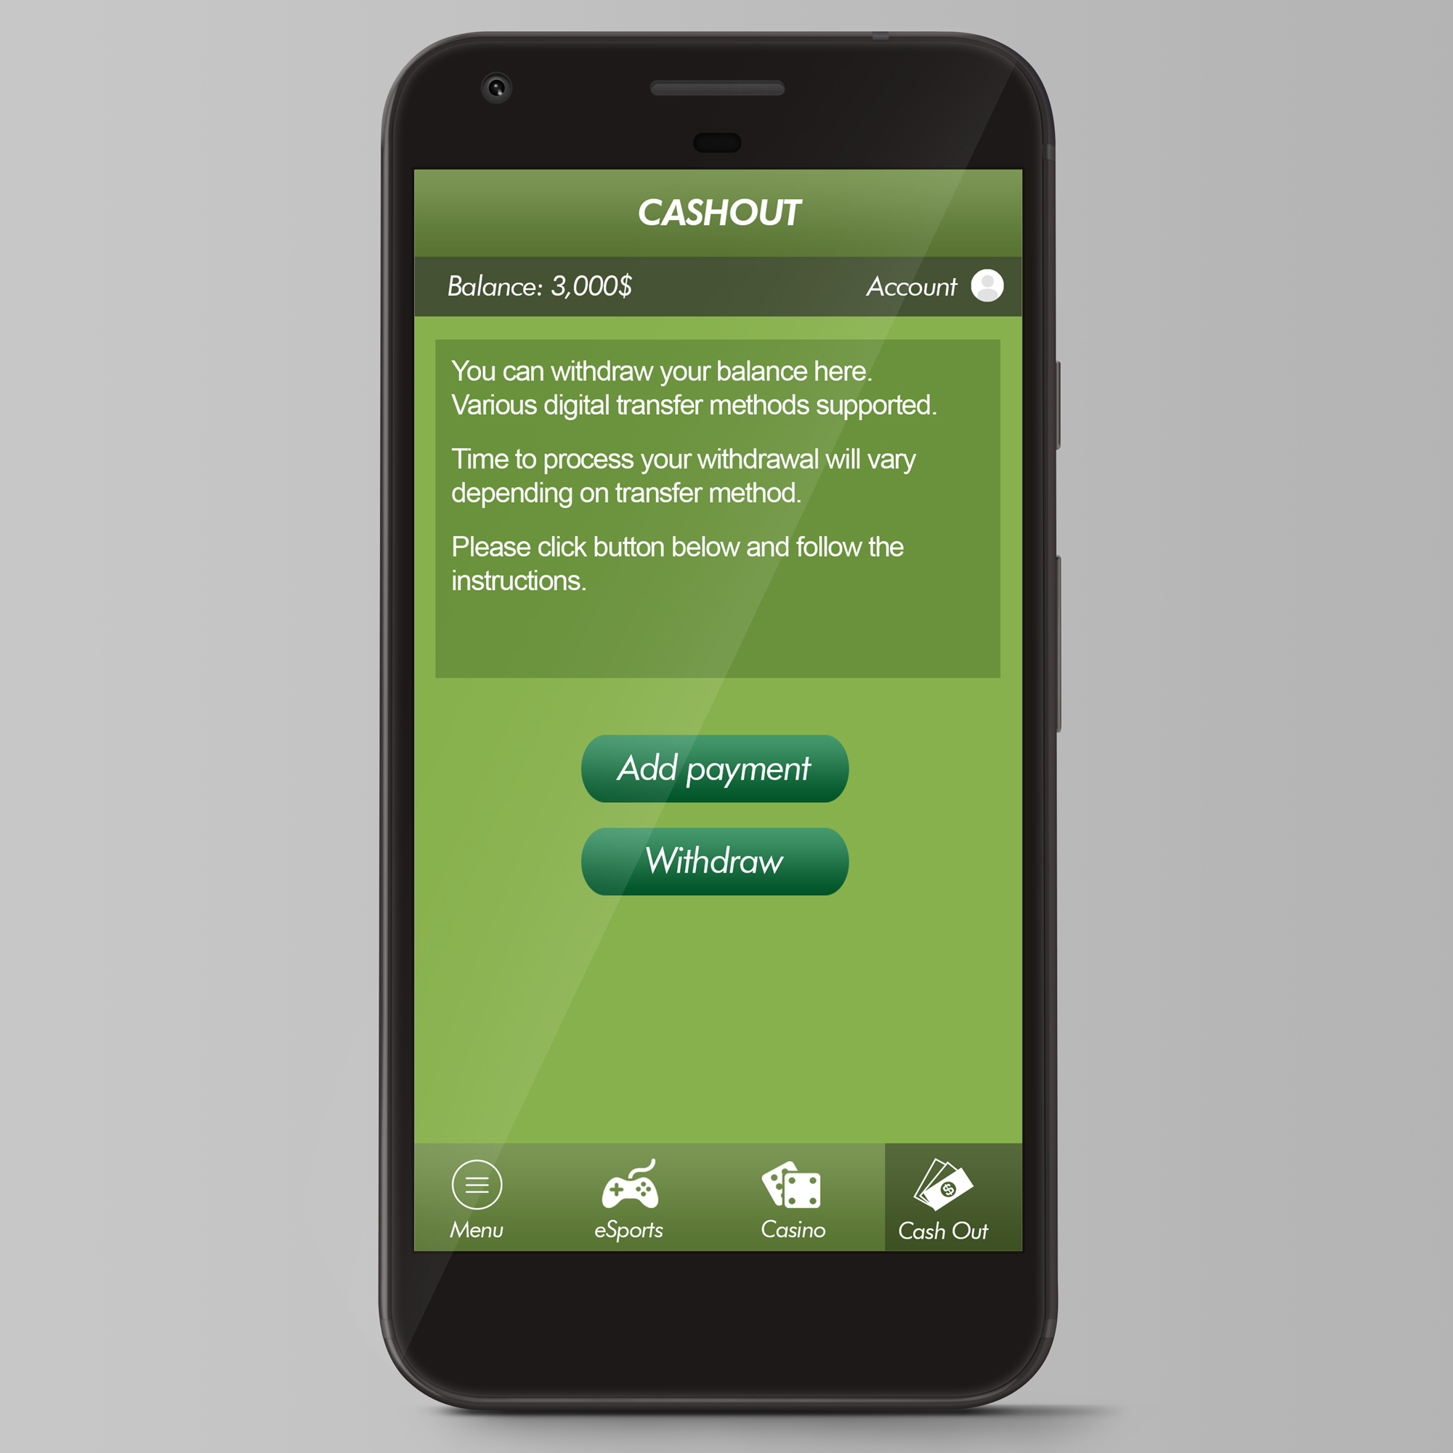

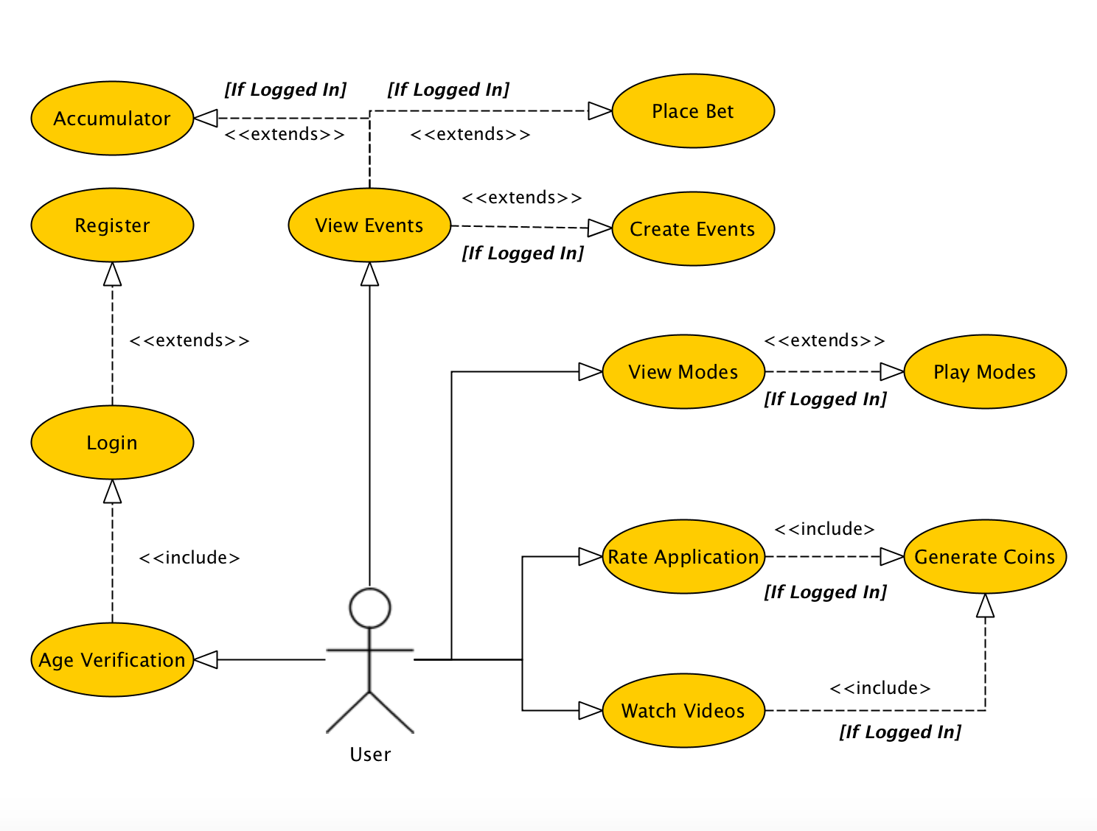VitonBet Use Case

**1. Age Verification**

**a.** The user is promoted with a verification screen where the user must only click

yes, if he/she is over 18.

**b.** The application will close if the user clicks no.

**2. Login**

**a.** The user enters in the username and password.

**b.** The user clicks the **Login** button.

**c.** System validates the username and password entered by the user.

**d.**

**i. Normal Flow:** User is brought to the main screen.

**ii.** **Alternative Flow:** If invalid, an error message is displayed.

**3. Register**

**a.** The user opens the registration page by clicking “Register” on the button below the login field.

**b.** The user enters in the details such as **username, password, phone number, address** and other personal information.

**c.** User clicks the **Submit** button.

**d.** System validates the information that was entered and also checks to see if the username is not in use.

**e.**

**i. Normal Flow:** User is brought to the main screen.

**ii. Alternative Flow:** If invalid, an error message is displayed.

**4. View Events**

**a.** Whether the user is logged in or not, the user is able to view events when clicked passed the age verification screen.

**b.** User can scroll up and down to view events.

**5. Create Events (Extended if the user wants to create an event).**

*Only if the user is logged in.*

**a.** The user clicks the “Create event” button.

**b.** The user then fills in the details for the event.

**c.** The user clicks “Create” to create the event.

**d.** System validates the information that was entered is correct and suitable for the event.

**e.**

**i. Normal Flow:** User is brought to the event screen to see the event created.

**ii. Alternative Flow:** If invalid, an error message is displayed.

**6. Place Bet (Extended if the user wants to place a bet).**

*Only if the user is logged in.*

1. The user clicks on the team or person he or she favors to win.
2. Betting confirmation to show the odds and the person or team the user has favored.

**c.** The user clicks “Place bet”.

**d.** System validates if the user has the sufficient funds.

**e.**

**i. Normal Flow:** User is brought to the main screen.

**ii. Alternative Flow:** If invalid, an error message is displayed.

**7. Accumulator (Extended if the user wants to place an accumulator).**

*Only if the user is logged in.*

1. The user clicks on the teams or people he or she favors to win,
2. Betting confirmation to show the total odds for the selected people and teams.

**c.** The user clicks “Place accumulator”.

**d.** System validates if the user has the sufficient funds.

**e.**

**i. Normal Flow:** User is brought to the main screen.

**ii. Alternative Flow:** If invalid, an error message is displayed.

**8. Rate Application**

**a.** User selects “Rate VitonBet” from the navigator.

**b.** User enters in the rating.

**c.** User presses “Submit”.

**d.** System validates if the user has actually rated the application.

**e.**

**i. Normal Flow:** User is brought to the “Thank you” screen.

**ii. Alternative Flow:** If invalid, an error message is displayed.

**8. Watch Vidoes**

**a.** User selects “Free Currency” from the navigator.

**b.** User presses play on the generated video which is an advertisement.

**c.** Video finishes and user can press to watch it again or play another one.

**7. Generate Coins (Include if the user is logged in).**

1. Coins added automatically to the user’s account if the user reviewed the app or watched a video advertisement.
2. VitonBet Database

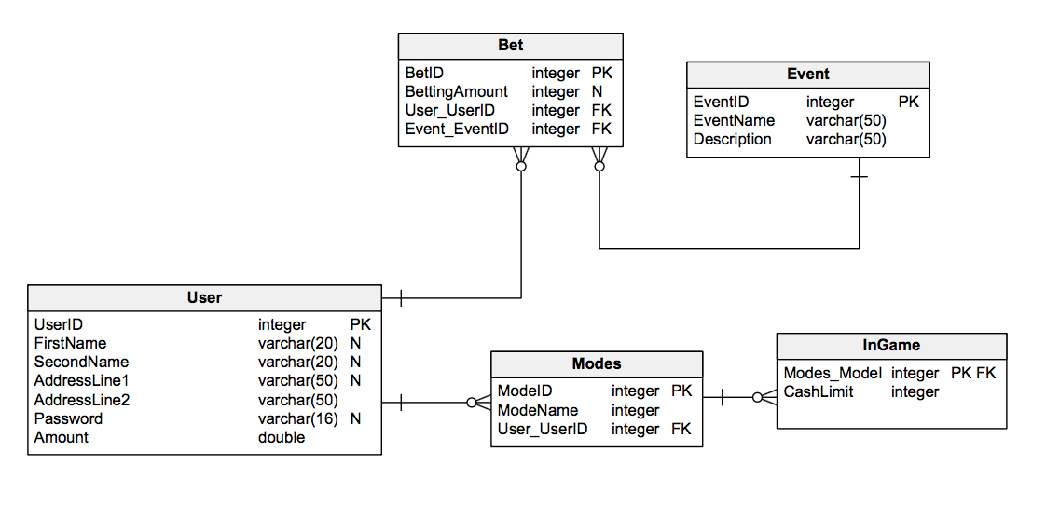

The database above is a rough idea of what our database will look like, it is not set for the final release of the database as usually databases changes as you work on the application or update it.

This is the first version of our database and it will be changed and improved as we go along making the app.

**User Table**

The user table will be the main table where each user will be identified. Almost every application may be using something similar as to using this User table.

The User table will keep hold of the UserID which is unique and to make sure a user can be distinguished from the rest.

Main columns such as first name, second name, address just to hold some information about the user.

The password column is what’s going to hold the user’s password to authenticate that person to log in, we will salt the password in the database so the actual password doesn’t show, it will be encrypted.

Amount will hold the amount of cash the user has. So, the user can win events, the amount will be updated and so on.

**Bet Table**

The bet table is linked to the user table as every user can place a bet, the Bet table will store the ID of that bet and the betting amount this table is also linked to the event table.

**Event Table**

The event table is linked to the bet table, this is needed as every user can place a bet and every bet should have an event.

We want to know more about the bet so the name of the event and the description of that event. It can be like a match in a particular game where you have a team taking on another team.

**Modes Table**

Modes will hold the different type of modes available to be played, such as I mentioned before the casino mode.

**InGame Table**

This table and modes table will be changed as we work on our app but for now we are going to include a cash limit for the amount a user can spend in a particular mode.